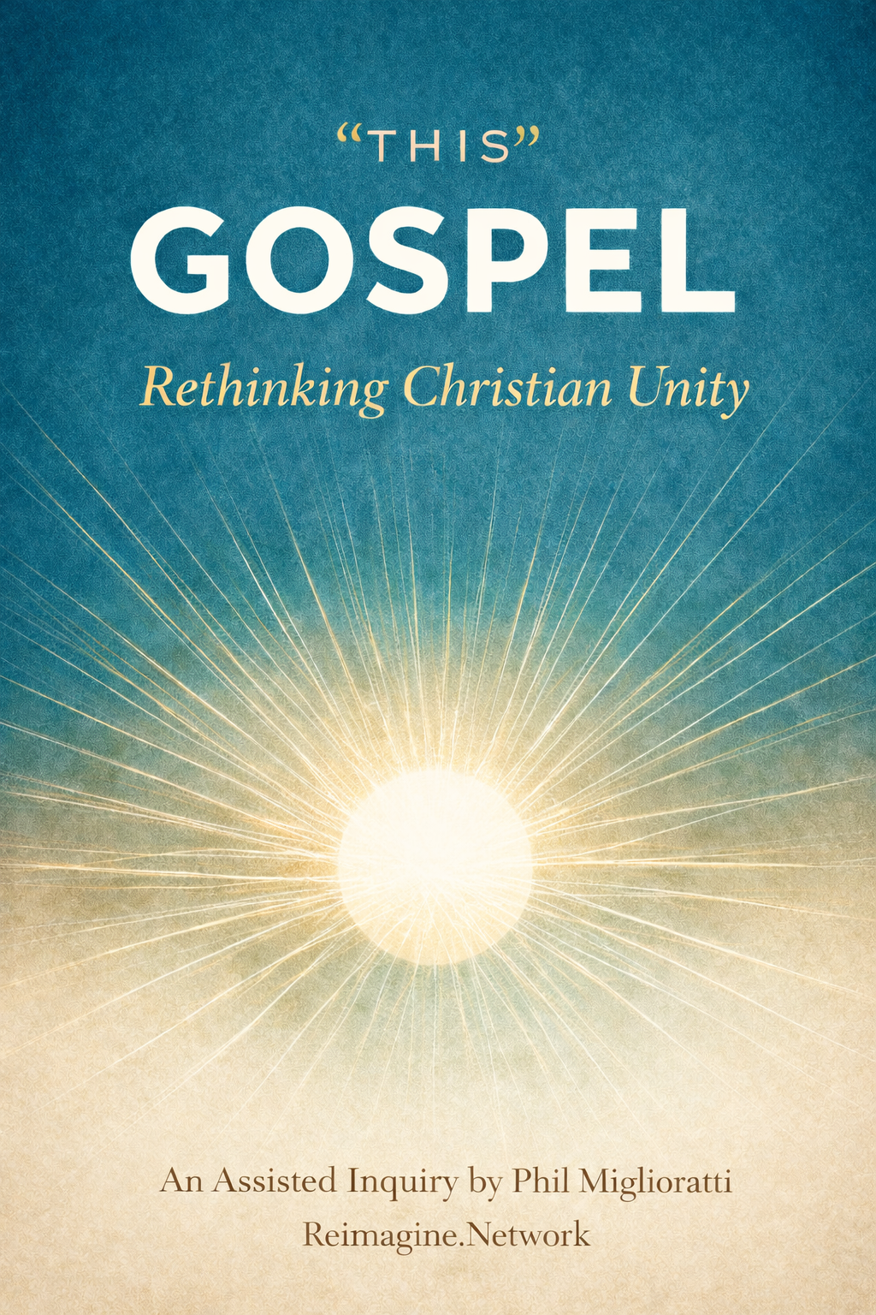

“THIS GOSPEL”

Re-Thinking Christian Unity
An Assisted Inquiry by Phil Miglioratti {with AI}
This is not a formal essay or theological monograph. I am presenting a selection of “modules” for your thoughtful pondering. It is a modular idea/resource/workshop guide.
Inquiry: a request for information, a systematic investigation, often a matter
of widespread interest, examination into facts or principles, research. {to seek, look into)

“Modules are parts, components, units, sections, elements, and building blocks, while more specific terms depend on context, such as courses/chapters (education), assemblies/plug-ins (technology), or segments/features (general/technical). Essentially, any word meaning a self-contained piece making up a larger system work.”
They may also serve as a resource to your personal study, a group discussion, a sermon or seminar teaching, and/or as a printable handout. Use as your Think Bank.
My prayer is for you to have a Spirit-led, Scripture-fed experience that guides you to reimagine the Body of Christ in a way that impacts how you pray-for, show-honor, and serve-with across the denominational spectrum.
Each member of the Family of God must embrace, albeit difficult at times, their sisters and brother.
“But now you belong to Christ Jesus. At one time you were far away from God. Now you have been brought close to Him. Christ did this for you when He gave His blood on the cross. We have peace because of Christ. He has made the Jews and those who are not Jews one people. He broke down the wall that divided them. ¹⁵ He stopped the fighting between them by His death on the cross. He put an end to the Law. Then He made of the two people one new kind of people like Himself. In this way, He made peace. He brought both groups together to God. Christ finished the fighting between them by His death on the cross. Then Christ came and preached the Good News of peace to you who were far away from God. And He preached it to us who were near God. Now all of us can go to the Father through Christ by way of the one Holy Spirit. From now on you are not strangers and people who are not citizens. You are citizens together with those who belong to God. You belong in God’s family. This family is built on the teachings of the missionaries and the early preachers. Jesus Christ Himself is the cornerstone, which is the most important part of the building. ²¹ Christ keeps this building together and it is growing into a holy building for the Lord. (Ephesians 2:13-21)

© Phil Miglioratti • 2026 • Permission to Post-Project-Print * Free but a Donation Helps Future Leaders
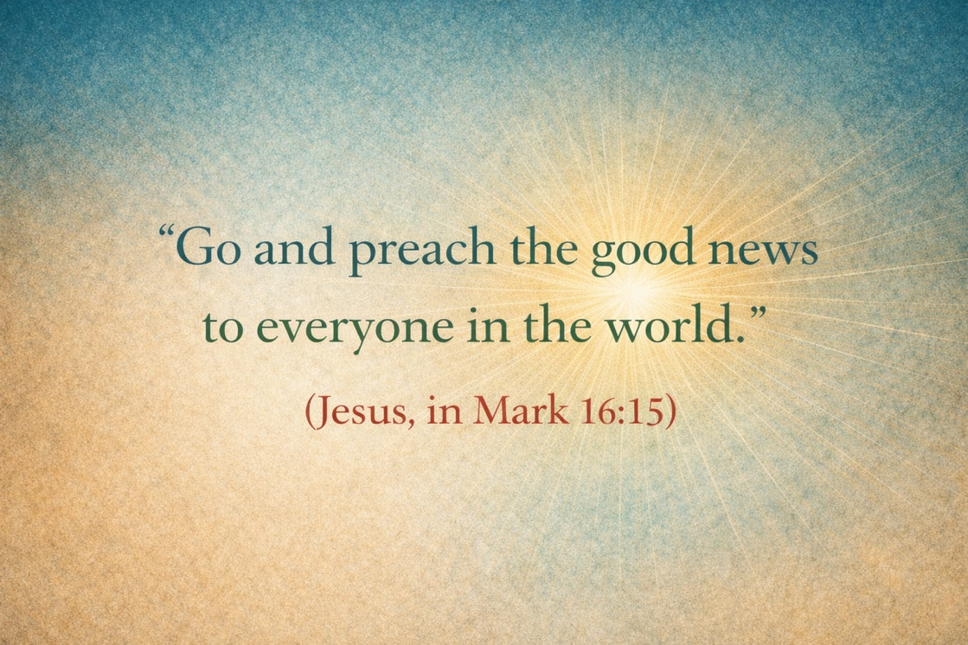
Your Inquiry Journey
PROLOGUE
PRELUDE: The Parable of the Ice Cream Shop
ONE ~ Why Reassess?
TWO ~ What Do We Mean By “This Gospel”?
THREE ~ The Gospel and Mission Today
FOUR ~ The State of Our (dis) Union
FIVE ~ Mapping the 25 Distinct Expressions of Christianity by Orientation
SIX ~ Interview: What Is “This Gospel”?
SEVEN ~ Jesus’ Gospel Before Our Systems and Doctrinal Statements
EIGHT ~ Paul’s Gospel Is Not a Different Gospel
NINE ~ One Gospel, Three Dimensions, Many Expressions
TEN ~ One Shared Seven-Word “Lowest Common Denominator” Gospel
ELEVEN ~ How This Minimalist Gospel Compares to Jesus’ Own Summaries
TWELVE ~ Testing the Minimalist Gospel Against Paul’s Own Summaries
THIRTEEN ~ How Mission Agencies Implicitly Choose a Gospel Orientation
FOURTEEN ~ A Teaching Framework Pastors Can Use (Without Triggering Defensiveness)
FIFTEEN ~ A Unifying Re-View
- BONUS: The Parable of the Ice Cream Shop: Explanation, Illustration, Sermons, Facilitating Discussion, Mapping Traditions
- BONUS ~ Suggestions on Pursuing Unity
- BONUS ~ The Parable of God’s Global Choir
“My prayer is not for them alone. I pray also for those who will believe in me through their message, that all of them may be one, Father, just as you are in me and I am in you
(Jesus, in John 17:21-22)

______________

PROLOGUE
“In John 17, Jesus prays for the unity of all believers, asking that they may be "one" just as He and the Father are one, so the world will believe God sent Him. This prayer, often called the High Priestly Prayer, emphasizes a deep spiritual oneness in love, truth, and purpose, reflecting the Trinity's unity, not mere uniformity, allowing believers to share the Father's glory and demonstrate God's love to the world.” [AI]
These questions fuel my inquiry:
What if Jesus petitioned the Father for our unity because he knew even his most faithful followers would be unable to agree on every theological jot-and-tittle?
What if his prayer for unity has nothing to do with our theological statements and systems?
What if Jesus was asking the Father to reveal to Christ followers that “There is neither Jew nor Greek, there is neither slave nor free, there is no male and female, for you are all one in Christ Jesus”? (Galatians 3:28)
What if that means God is using our varied worship styles, modes of baptizing, eschatological emphases, disciple-making methods, evangelistic models, and even our differing doctrinal distinctions to reach every person in every place with every worldview perspective.
Could it be when Jesus told his disciples to “Go and preach the good news to everyone in the world. (Mark 16:15), he was anticipating our plethora of denominations and ministries and expressions?
Could it be Jesus expects us to be different (not heretical, just not identical) and the Holy Spirit is prepared to use our differences to reach the many varied peoples in vastly different locations/situations who have diverging perspectives and purposes?
With “this Gospel.” (Mark 13:10)

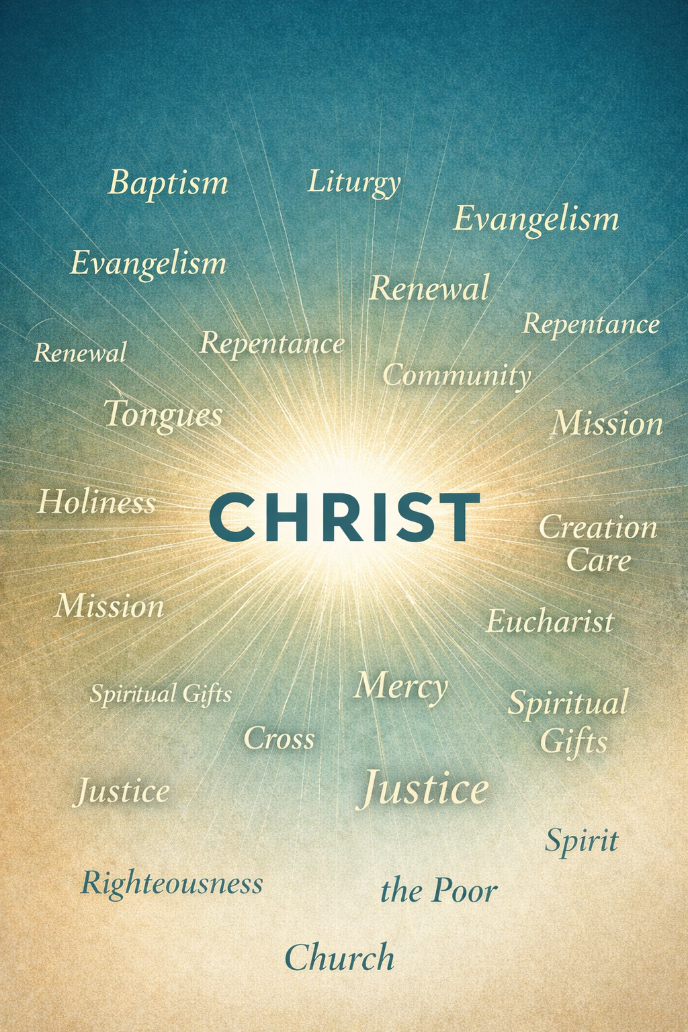


PRELUDE: The Parable of the Ice Cream Shop
{Before mapping differences, we must first ask why this conversation matters at all}

There was an ice cream shop on the corner of a busy town.
Above the door hung a sign that read: 31 Flavors
People came from everywhere—children and elders, locals and travelers, skeptics and seekers. The bell rang each time the door opened.
They loved the shop, especially the shopkeeper.
Inside, the freezers stretched along the wall, filled with flavors as far as the eye could see.
Some people walked straight to the counter and said,
“Chocolate. Always chocolate.”
They didn’t want to sample. They didn’t need variety. Chocolate had been faithful to them since childhood. It tasted like certainty. It tasted like home.
Others studied the menu carefully.
“I’ll have Neapolitan,” they said.
They liked the balance—chocolate, vanilla, strawberry together. One flavor alone felt incomplete. They wanted contrast, harmony, a reminder that sweetness could come in more than one form at the same time.
Some chose vanilla—but not plain.
“Vanilla with peanut butter,” they said.
They loved the simplicity of vanilla, but they needed something richer mixed in—something that stuck, something that gave depth. Vanilla alone felt too quiet for the life they had lived.
Others asked for flavors few people noticed.
“Pistachio” …. “Rum raisin” … “Mint chip—but only if it’s real mint.”
They had tasted things before that left them cautious. They wanted something honest, something that surprised them without overpowering them.
Children pressed their noses to the glass and pointed wildly.
“I want that one—the bright one!”
They didn’t yet have words for preference. They only knew delight.
A few stood off to the side, arms crossed.
“I don’t like ice cream,” they said.
But sometimes, quietly, they asked for a spoonful to try.
And then there were those who argued.
Chocolate-only people insisted chocolate was the real flavor.
Vanilla lovers said chocolate was too heavy.
Those who loved fruit said dairy itself was the problem.
They debated textures. They debated ingredients. They debated what ice cream was meant to be.
Meanwhile, the shopkeeper watched.
He had made every flavor himself. Same milk. Same cream. Same source.
Different recipes—not to confuse people, but to attract them, to welcome them.
When the arguing grew loud, he stepped forward and said,
“You are all here because you are hungry, craving the delicious refreshment of ice cream.”
They fell quiet.
“You are not choosing different foods.
You are responding to the same hunger, but everyone has been shaped by different stories, different circumstances have prompted you to be here today, and each of you has a distinct set of taste buds. Different flavors attract different people with their distinct set of needs and desires”
Someone asked, “Then which flavor is the right one?”
The shopkeeper smiled.
“The one that brings you inside.
The one that keeps you coming back.
The one that reminds you how much sweetness satisfies.”
He paused, then added,
“But don’t mistake your favorite shop or flavor for the ice cream itself.
And don’t despise another’s taste because it isn’t yours. And most of all, remember that as much as you enjoy your favorite flavor, it only tastes good is because of the ice cream shop proprietor.”
Outside, the bell rang again.
Another person entered.
And the shop remained open.

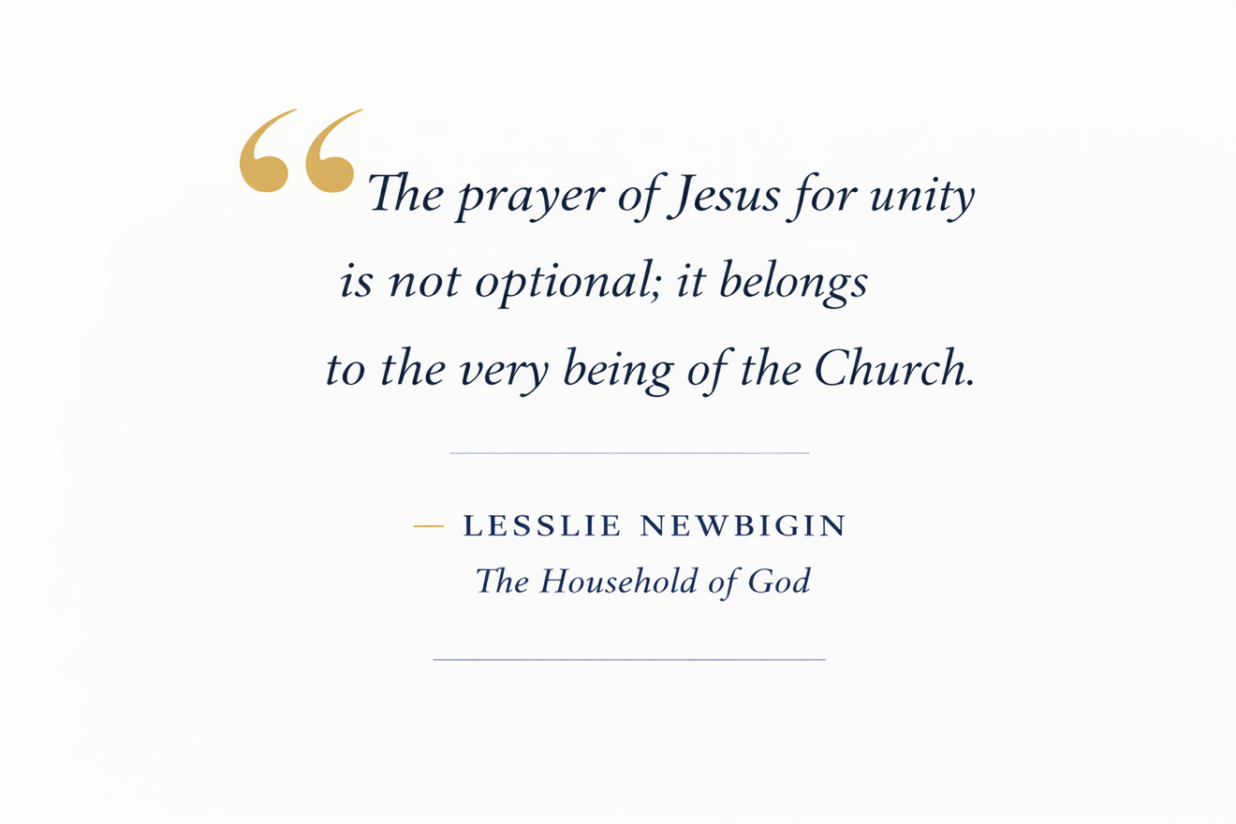

ONE ~ Why Reassess?
Jesus declared “this Gospel must be preached to all peoples” (Mark 13:10).
Yet Christians, true believers in and followers of Jesus, often disagree—sometimes passionately—about what exactly “this Gospel” is.
Disagreeing that should lead to discussion or investigation more often produces distance even disdain between differing expressions of Christian faith.
Maybe Jesus knew how difficult it would be for his followers to agree on every “jot and tittle.”

I want all of them to be one with each other, just as I am one with you and you are one with me. I also want them to be one with us. Then the people of this world will believe that you sent me. (John 17:21)

This inquiry seeks to discover/recover a shared center of Christian proclamation by listening carefully to Jesus, to Paul, and to the global Church.
It seeks clarity without reduction, unity without uniformity, and faithfulness without fear of unholy alliances. It hopes a re-viewing of Christianity from a what-we-share-in-common perspective rather than a what-important- but-secondary-issues do we debate lead to division. The Christian family (the “Ekklesia“) does not require complete doctrinal agreement; it does require a humility (no one expression is the only holder of truth) and respect (God seeks to work in every Christian movement to bring reconciliation to every nation/people group).
Jesus said that “this Gospel must be preached to all peoples” (Mark 13:10).
Yet Christians often disagree—sometimes passionately—about what exactly “this Gospel” is.
Some emphasize forgiveness of sins.
Some emphasize personal salvation.
Some emphasize justice, healing, or deliverance.
Some emphasize the kingdom of God, discipleship, or transformation.
This inquiry does not seek to flatten those differences.
Nor does it attempt to rank them.
Instead, this inquiry seeks to recover the shared center of Christian proclamation by listening carefully to Jesus, to Paul, and to the global Church. It seeks clarity without reduction, unity without uniformity, and faithfulness without fear.

“Accept the one whose faith is weak, without quarreling over disputable matters.”
(Romans 14:1)

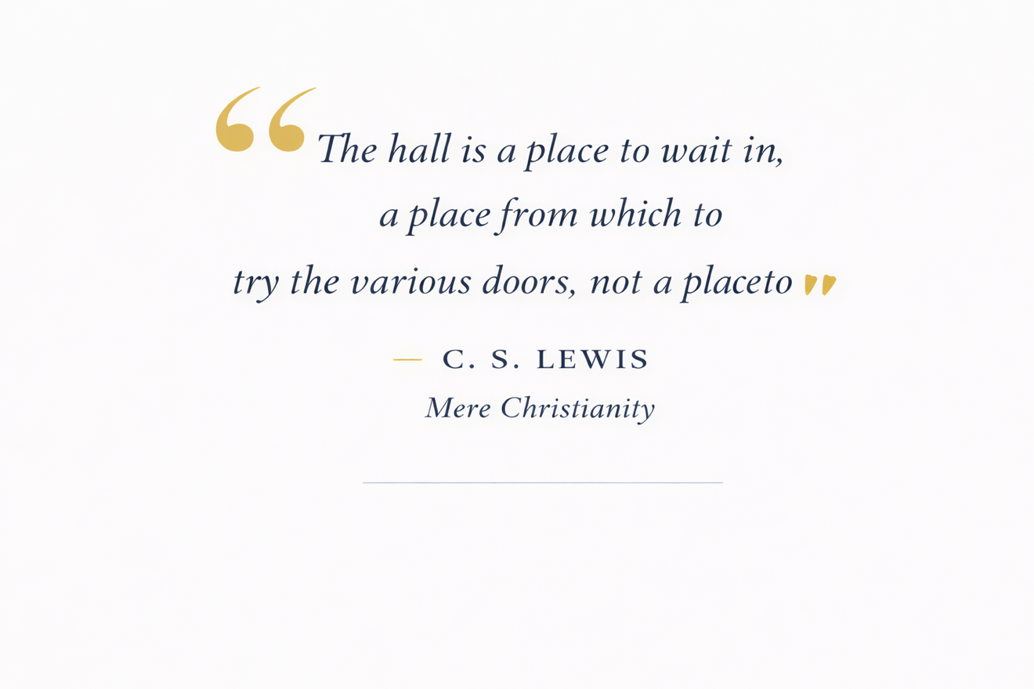

TWO ~ What Do We Mean by “This Gospel”?

{Having named the problem, we must now clarify the language}

“The beginning of the good news about Jesus the Messiah, the Son of God.” (Mark 1:1)

The Christian Gospel has never lacked (nor should it lack) passion.
What it has often lacked is clarity. Across cultures, centuries, and denominations, Christians have emphasized different aspects of the same good news. These emphases are rarely contradictions; more often, they are faithful responses to different human needs and historical moments.
When reduced to its irreducible core, the shared Christian confession is remarkably simple:
Jesus Christ is Lord, bringing God’s salvation.
This confession is expansive enough to include forgiveness, healing, liberation, reconciliation, justice, transformation, and hope—yet specific enough to remain unmistakably Christian.
“Jesus came into Galilee, proclaiming the good news of God.
‘The time has come,’ he said. ‘The kingdom of God has come near.
Repent and believe the good news.’” (Mark 1:14–15)

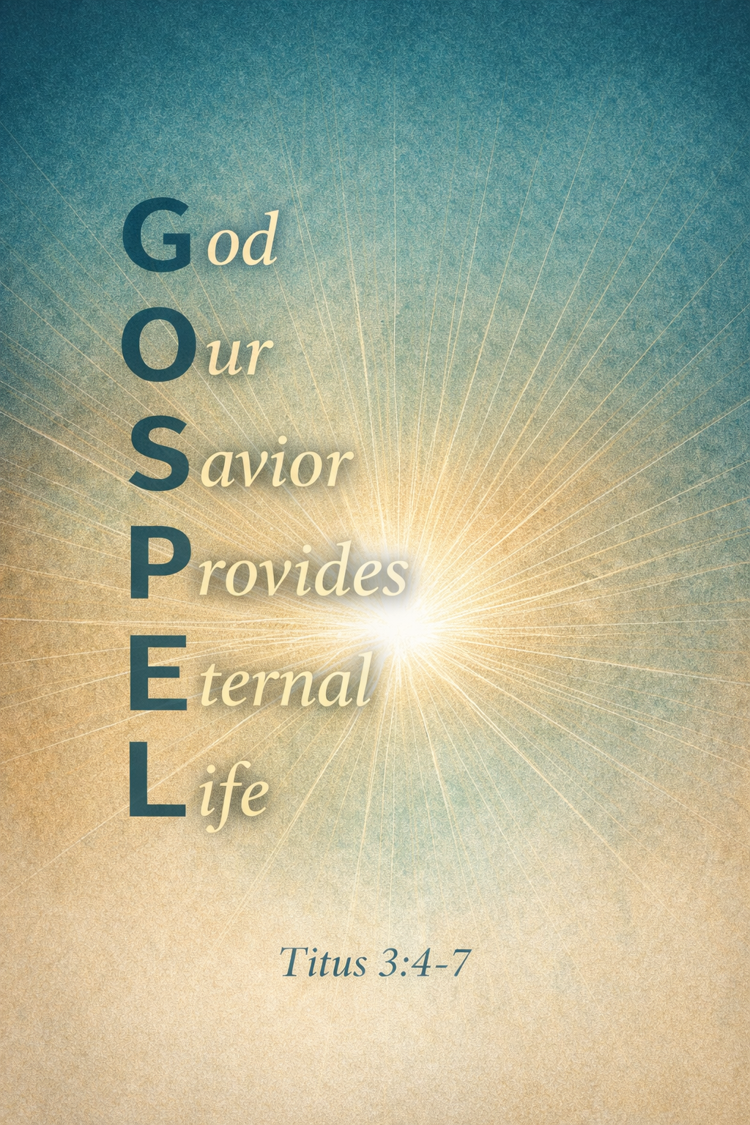

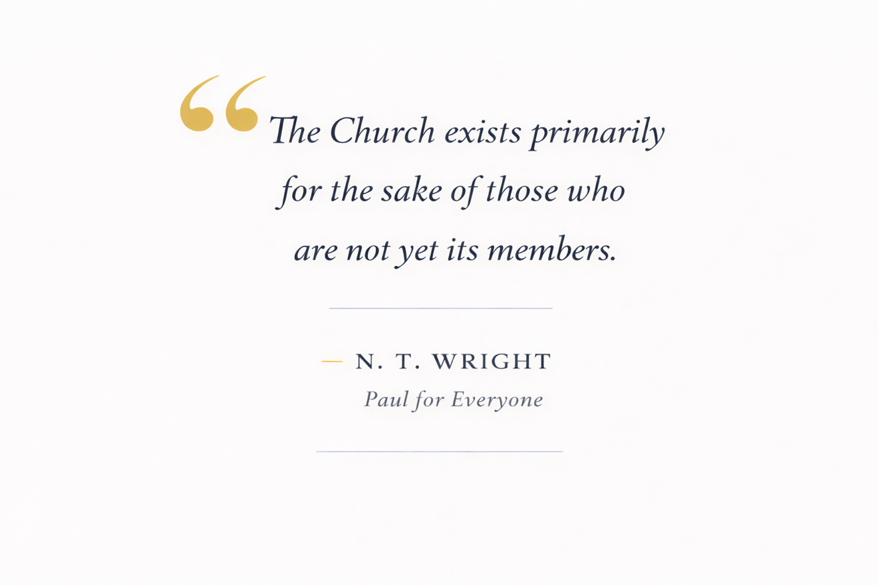

THREE ~ The Gospel and Mission Today
{Clarifying the gospel inevitably raises questions about how it is lived and shared.}

Mission debates often arise not because Christians deny the Gospel, but because they over-specialize in one dimension of it.
Some emphasize proclamation and decision.
Some emphasize justice and compassion.
Some emphasize power, healing, and renewal.
Healthy mission integrates announcement, embodiment, and expectation.
When one dimension is isolated, mission becomes distorted.
When all three are held together, mission becomes faithful and credible.
Healthy mission does not choose between these emphases.
It integrates them.
The Gospel announces what God has done in Christ.
The Gospel embodies what that announcement means for life together.
The Gospel anticipates the renewal of all things under Christ’s reign.
When any one dimension is isolated, mission becomes distorted.
When all three are held together, mission becomes faithful, credible, and compelling.

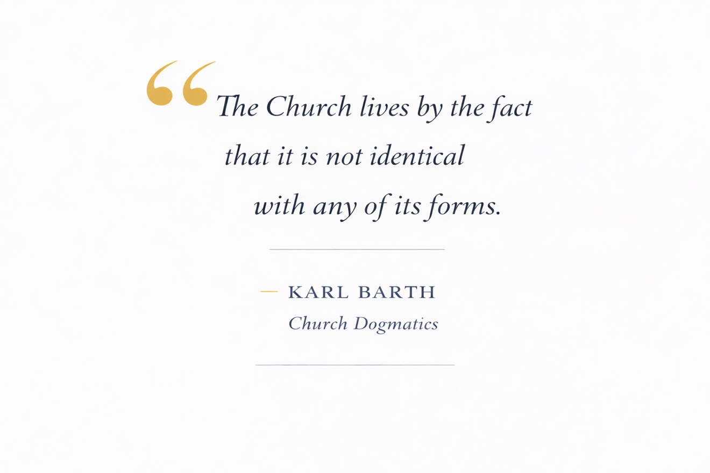

FOUR ~ The State of Our (Dis)Union
{To understand our disagreements, we must first see them clearly}

{NOTE: These are self-understandings, not critiques

Each description reflects how that tradition/commonly articulates the good news}

A Comparative, Descriptive Map:

How 25 Major Expressions of Christianity Describe “This Gospel”

“The Good News must be told to all people.” (Mark 13:10)
“One Lord, one faith, one baptism.”
(Ephesians 4:5)

1. Roman Catholic
The Gospel is the proclamation of Jesus Christ as Lord, bringing salvation through grace, mediated sacramentally through the Church, calling people into communion with God, moral transformation, and participation in God’s kingdom—personally and socially.

2. Eastern Orthodox
The Gospel is the announcement of Christ’s victory over sin, death, and corruption, inviting humanity into theosis (participation in the divine life) through repentance, worship, and union with Christ in the Church.

3. Anglican / Episcopal
The Gospel is the good news of Jesus Christ crucified and risen, reconciling humanity to God, forming a redeemed community shaped by Scripture, sacrament, reason, and mission for the renewal of the world.

4. Lutheran
The Gospel is the declaration that sinners are justified by grace alone through faith alone in Christ alone, apart from works—free forgiveness grounded entirely in Christ’s finished work.

5. Reformed / Calvinist
The Gospel is the sovereign work of God in Christ to redeem the elect, reconcile sinners, establish God’s kingdom, and restore all creation—centered on God’s glory and covenant faithfulness.

6. Presbyterian
The Gospel is the announcement of God’s reconciling grace in Jesus Christ, restoring individuals and communities, calling people into covenant life marked by discipleship, justice, and mission.

7. Methodist / Wesleyan
The Gospel is the good news of God’s prevenient, justifying, and sanctifying grace, calling people to new birth, holy living, and participation in God’s redemptive work in the world.

8. Baptist (Evangelical)
The Gospel is the message that Jesus died for our sins, was buried, and rose again, offering personal salvation through repentance and faith, followed by believer’s baptism and discipleship.

9. Pentecostal
The Gospel proclaims Jesus as Savior, Healer, Baptizer in the Holy Spirit, and Coming King, calling people to repentance, Spirit-empowered living, signs and wonders, and global witness.

10. Charismatic (across denominations)
The Gospel is the living reality of Christ’s Lordship and present power, demonstrated through spiritual gifts, healing, prophetic witness, and transformed lives in the power of the Spirit.

11. Non-Denominational Evangelical
The Gospel is the invitation to a personal relationship with Jesus Christ, offering forgiveness of sins, new life, and eternal salvation through faith, grounded in Scripture.

12. Anabaptist (Mennonite, Amish, Brethren)
The Gospel is the call to follow Jesus in daily life, embodying peace, nonviolence, community, simplicity, and obedience as visible signs of God’s kingdom.

13. Moravian
The Gospel is the message of the Lamb of God who takes away the sin of the world, inspiring devotion, unity, and missionary witness rooted in Christ’s sacrificial love.

14. Seventh-day Adventist
The Gospel is the proclamation of Christ’s saving work, the nearness of His return, obedience to God’s commandments, holistic health, and the cosmic conflict between good and evil.

15. Holiness Movement
The Gospel announces salvation and entire sanctification, calling believers into a Spirit-filled life marked by holiness, love, and victory over sin.

16. Reformed Charismatic
The Gospel is God’s sovereign act of salvation in Christ, applied powerfully by the Spirit, advancing the kingdom through Word, sacrament, and spiritual gifts.

17. African Indigenous Churches
The Gospel is the good news that Jesus Christ delivers from spiritual powers, heals bodies and communities, restores dignity, and reigns as Lord over all aspects of life.

18. Latin American Liberation Theology
The Gospel is the announcement of God’s preferential option for the poor, liberation from oppression, and the inbreaking of God’s justice through Christ for both soul and society.

19. Black Church Tradition
The Gospel proclaims Jesus as liberator and redeemer, bringing salvation, hope, dignity, and justice in the midst of suffering, oppression, and historical trauma.

20. Mainline Protestant (Progressive)
The Gospel is the message of God’s inclusive love revealed in Jesus, calling humanity toward reconciliation, justice, compassion, and participation in God’s renewing work.

21. Evangelical Missional Movement
The Gospel is the announcement of God’s reign inaugurated in Jesus, inviting people to align their lives, communities, and cultures with God’s redemptive mission.

22. House Church / Simple Church Movements
The Gospel is the reproducible message of Jesus as Lord, forming small, Spirit-led communities of obedience, discipleship, and multiplication.

23. Emerging Church
The Gospel is the story of God’s redemptive love revealed in Jesus, inviting people into authentic relationship, restored community, and faithful presence in a fractured world.

24. Eastern Catholic
The Gospel is the proclamation of Christ’s incarnation, death, resurrection, and glorification, uniting salvation, worship, mystery, and transformation in communion with the universal Church.

25. Global South Evangelical Movements
The Gospel is the announcement of Jesus Christ as living Lord, bringing forgiveness, deliverance, community renewal, moral transformation, and hope amid poverty, persecution, and instability.

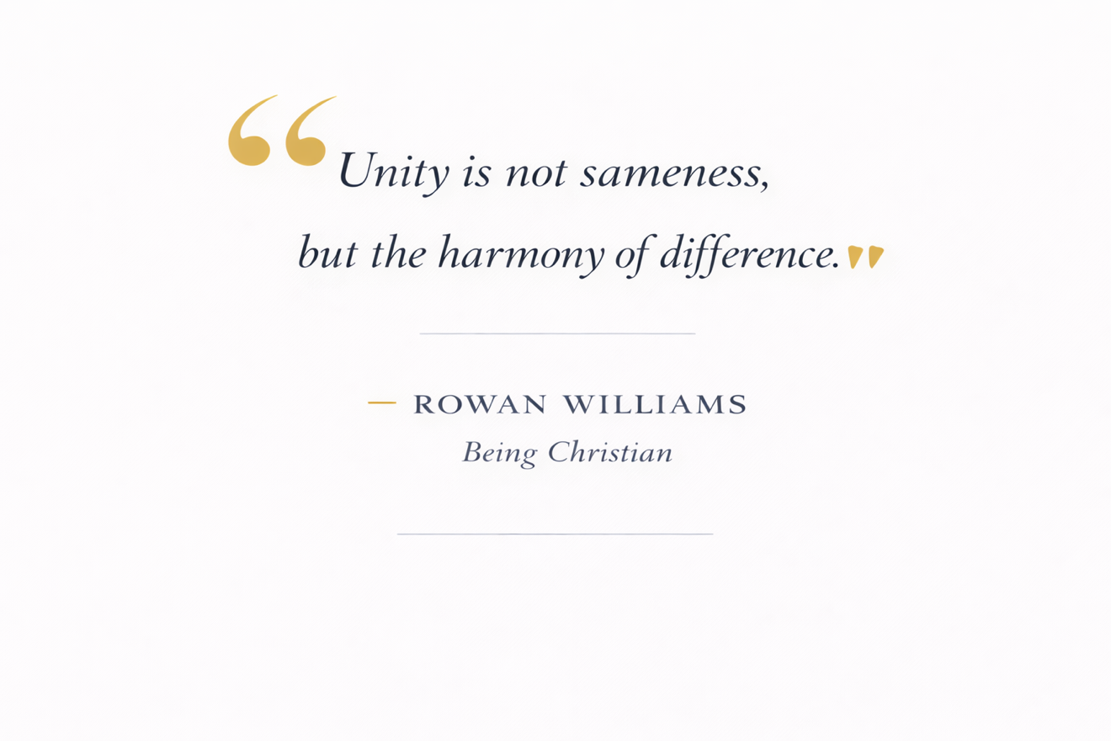

FIVE ~ Mapping the 25 by Gospel Orientation
{Patterns begin to emerge once these expressions are viewed side-by-side}

(Vertical • Horizontal • Cosmic)
No tradition is the one-and-only direction — but the world needs all three

A. Vertical Emphasis
(God ↔ humanity: forgiveness, justification, reconciliation)
- Lutheran
- Reformed / Calvinist
- Baptist (Evangelical)
- Non-Denominational Evangelical
- Moravian
- Holiness Movement
Minimalist frame: God saves sinners through Jesus Christ

B. Horizontal Emphasis
(People ↔ people: justice, community, liberation, discipleship)
- Anabaptist
- Liberation Theology
- Black Church Tradition
- Mainline Protestant (Progressive)
- Emerging Church
- Evangelical Missional Movement
Minimalist frame: God renews communities through Christ

C. Cosmic Emphasis
(Creation-wide: kingdom, victory, restoration, new creation)
- Eastern Orthodox
- Roman Catholic
- Anglican
- Pentecostal
- Charismatic
- Seventh-day Adventist
- African Indigenous Churches
- Global South Evangelical
- Eastern Catholic
Minimalist frame: Christ reigns, restoring all things

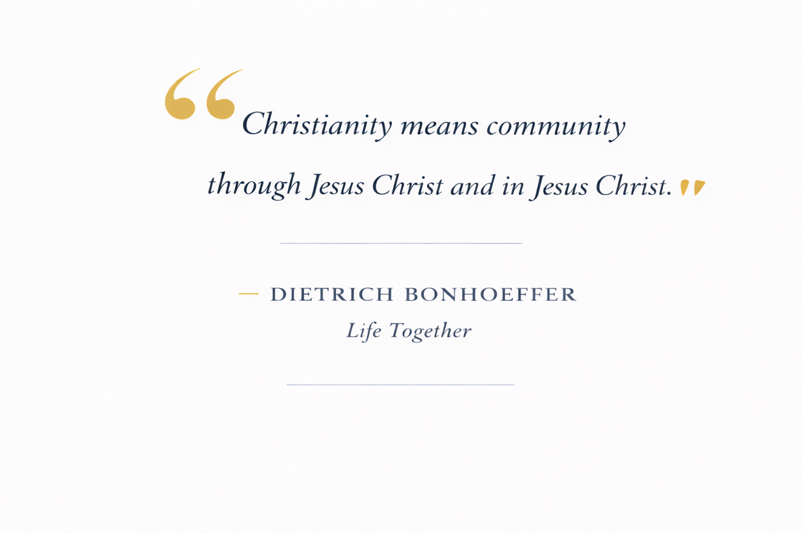

SIX ~ Interview: “What Is ‘This Gospel’?”
{Before moving further into synthesis, we pause to listen}

A Conversation Between PHIL and CHAT
“Come and see.” (John 1:46)

PHIL:
We’ve been talking about Mark 13:10—“This Gospel must be preached to all peoples.”
But Christians don’t always mean the same thing when they say “the Gospel.”
Before we get into details, can you summarize what all these expressions actually share?

CHAT:
When you strip away language, culture, and theological emphases, nearly every Christian tradition agrees on a core announcement:
Jesus Christ is Lord, bringing God’s salvation.
That sentence is broad enough to include forgiveness, healing, liberation, reconciliation, transformation, and hope—yet specific enough to remain unmistakably Christian.
In fact, if you reduce it further—dangerously so, but historically—
Jesus Christ is Lord
That single confession is the earliest Gospel proclamation of the Church.

PHIL:
That’s helpful. But how does that minimalist Gospel compare to Jesus’ own statements of the Gospel?

CHAT:
Jesus didn’t begin with mechanics—He began with announcement.
In Mark 1:14–15, Jesus says:
“The kingdom of God has come near. Repent and believe the good news.”
A minimalist rendering of Jesus’ Gospel would be:
God’s kingdom is here; respond in trust
In Luke 4, Jesus frames the Gospel as restoration: good news to the poor, freedom for captives, sight for the blind.
That becomes: God restores broken lives through Christ
And when Jesus calls disciples in Mark 8, the Gospel is simply: Come, follow me
Jesus’ Gospel always announces God’s reign, invites response, and points to transformation—personal, communal, and cosmic.
“I must proclaim the good news of the kingdom of God to the other towns also,
because that is why I was sent.” (Luke 4:43)

PHIL:
Some people argue that Paul changed the Gospel.
How does this minimalist Gospel hold up when tested against Paul’s own words?

CHAT:
When we let Paul speak for himself, the alignment is remarkably strong.
In 1 Corinthians 15, Paul summarizes the Gospel historically: Christ died, was buried, rose, and appeared.
That can be reduced to: Christ died, rose, reigns for us
In Romans 1, Paul says the Gospel declares Jesus as Son of God by resurrection:
Jesus declared Lord through resurrection power In 2 Corinthians 5, Paul expands the scope: “God was in Christ reconciling the world to himself.”
That becomes: God reconciles the world through Christ
Paul doesn’t replace Jesus’ Gospel—he clarifies its meaning and implications for the world.

PHIL:
You’ve talked about different “Gospel orientations.” Can you explain how Christian traditions tend to lean without turning this into camps or labels?

CHAT:
Most traditions don’t deny any part of the Gospel—but they emphasize different dimensions.
There are three dominant orientations:
Vertical — focused on reconciliation between God and humanity
God saves sinners through Jesus Christ
Horizontal — focused on transformed relationships and communities
God renews communities through Christ
Cosmic — focused on God’s reign restoring all creation
Christ reigns, restoring all things
Problems arise when one orientation is treated as the whole Gospel instead of part of it.
Jesus holds all three together.

PHIL:
That’s theology—but mission is where this gets practical.
How do mission agencies implicitly choose a version of the Gospel?

CHAT:
Most mission agencies don’t argue theology—they operate from assumptions.
Some ask:
“Have people believed?”
That’s a vertical emphasis—conversion, proclamation, decisions.
Others ask:
“Are lives and systems changing?”
That’s a horizontal emphasis—justice, compassion, development.
Others ask:
“Is the kingdom breaking in?”
That’s a cosmic emphasis—healing, deliverance, renewal.
Healthy mission requires all three:
- Proclamation
- Embodiment
- Expectation
Anything less exports a partial Gospel.

PHIL:
If pastors want to teach this without triggering defensiveness, how should they begin?

CHAT:
Start with Jesus, not definitions.
Begin with Mark 1:14–15, then ask:
What did Jesus announce before He explained anything?
Then introduce three reflective questions:
- What does the Gospel save us from and for?
- Who is being formed into a new way of life?
- What is God restoring beyond individuals?
People will recognize their own emphasis without being accused.
End not with a statement—but a confession: Jesus Christ is Lord
That creates alignment, not argument.

PHIL:
So, bringing this back to Mark 13:10— what makes “this Gospel” recognizable across all peoples?

CHAT:
It must be:
- Christ-centered
- Announced as good news
- Calling for response
- Big enough to address real human need
Which brings us back to the center:
The Gospel is the announcement that Jesus Christ is Lord,
and God is restoring all things through Him.
That Gospel can travel anywhere—and still be recognized as good news.

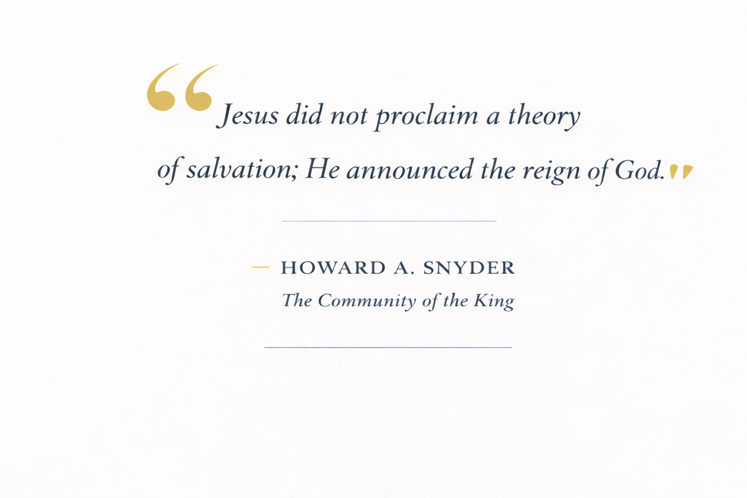

SEVEN ~ Jesus’ Gospel Before Our Systems and Doctrinal Statements
{To avoid protecting our encultured frameworks, we must return to Jesus}

“The kingdom of God has come near.” (Mark 1:15)
Jesus did not begin with theological systems or doctrinal checklists. He began with news. The reign of God was breaking into the world—confronting personal sin, social division, spiritual oppression, and cosmic disorder all at once.
Jesus summarized the Gospel in multiple ways, each revealing a different facet of the same good news:
- God’s kingdom is here; respond in trust.
- Come, follow me.
- The last shall be first.
- Love God and neighbor.
- I am the resurrection and the life.
“I am the resurrection and the life.
The one who believes in me will live, even though they die.”
(John 11:25)
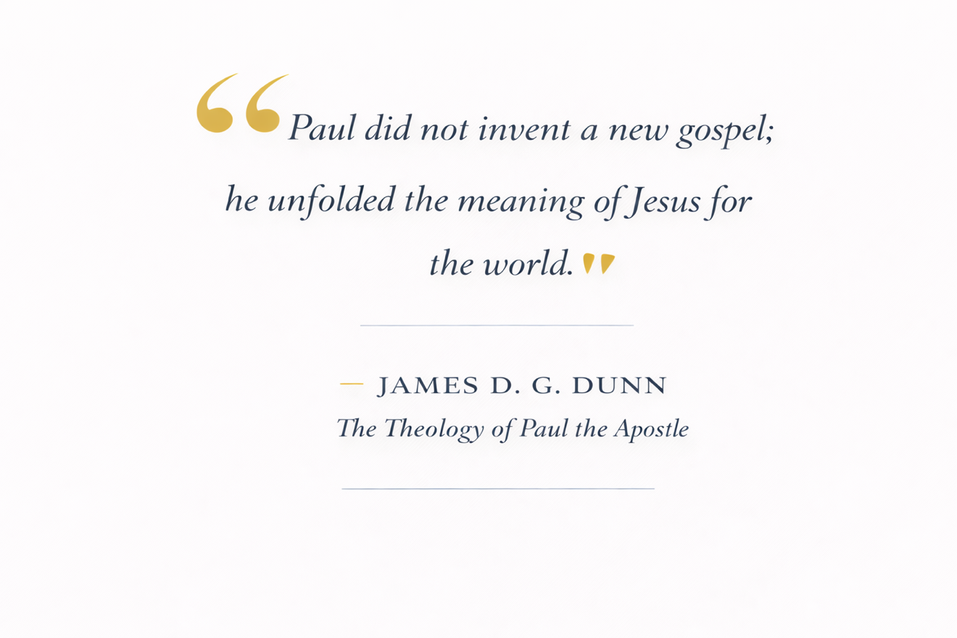

EIGHT ~ Paul’s Gospel Is Not a Different Gospel

{Biblical unity must include Paul as well as Jesus}

“We preach Christ crucified.” (1 Corinthians 1:23)
Paul did not replace Jesus’ Gospel; he proclaimed its meaning for a rapidly expanding, multiethnic world. Writing to communities wrestling with identity, law, power, and unity, Paul emphasized justification, reconciliation, and resurrection. Yet his Gospel remained Christ-centered, kingdom-oriented, and creation-wide.
Paul’s own summaries include:
• Christ died, was buried, and was raised (1 Corinthians 15).
• Jesus declared Lord through resurrection power (Romans 1).
• God reconciling the world through Christ (2 Corinthians 5).
“For what I received I passed on to you as of first importance:
that Christ died for our sins according to the Scriptures,
that he was buried, that he was raised on the third day.”
(1 Corinthians 15:3–4)

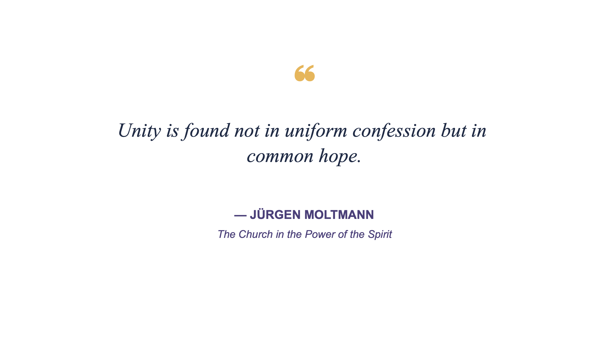

NINE ~ One Gospel, Three Dimensions, Many Expressions
{We must recognize our distinctions and differences are rooted in the living Gospel, our Lord and Savior Jesus, the Messiah}

“For from him and through him and for him are all things.” (Romans 11:36)
Throughout Christian history, the Gospel has been proclaimed through three interconnected dimensions.
- Vertical: reconciliation between God and humanity—
forgiveness, justification, salvation
- Horizontal: formation of a redeemed people—
discipleship, justice, and community
- Cosmic: restoration of all creation—
Christ’s reign, victory, and renewal
Each dimension possesses truth.
Every dimension has cultural or theological blind spots.
No expression of Christianity is infallible or inerrant.
Every dimension/expression is a good news invitation to Christ.
Jesus holds all three dimensions and every authentic expression together.
“Through him God was pleased to reconcile to himself all things,
whether on earth or in heaven, by making peace through his blood.”
(Colossians 1:20)

Facilitator/Workbook
Designed for individual reflection and group discussion.
- Which dimension of the Gospel do you emphasize most?
- Which dimension do you tend to neglect?
- How might the Gospel sound different in another culture and still be faithful?
- What makes the Gospel recognizable across all peoples?

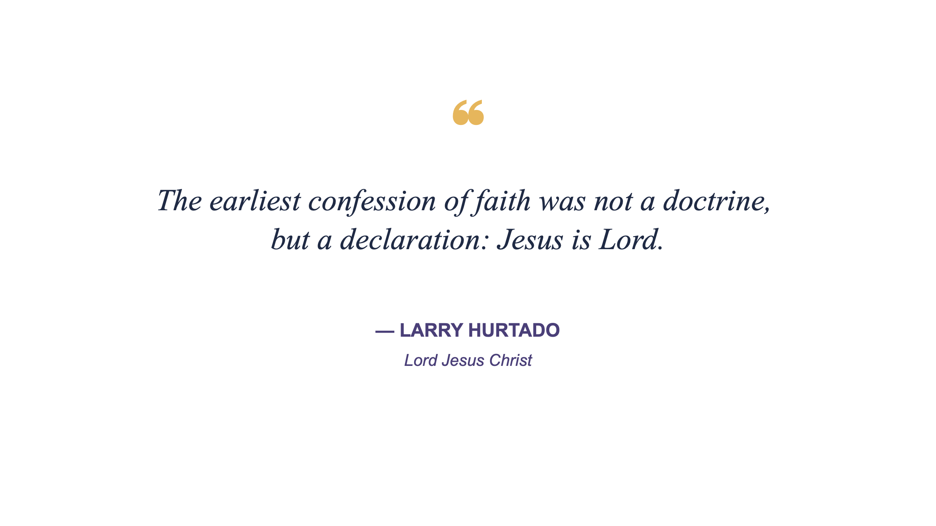

TEN ~ One Shared Seven-Word “Lowest Common Denominator” Gospel
{What we mean by unity must be easily explainable and compellingly expressible}

After compressing all 25 expressions, the strongest faithful minimalist—broad enough to include all, specific enough to remain Christian—is:

Jesus Christ is Lord, bringing God’s salvation
Why this works
- Jesus Christ — irreducible center
- is Lord — resurrection, authority, allegiance, kingdom
- bringing God’s salvation — broad enough to include forgiveness, healing, liberation, reconciliation, transformation, and hope
Every tradition can affirm this without betrayal of conscience, while still expanding it in their own theological language.
If reduced even further (dangerously so, but revealing):
Jesus Christ is Lord
That alone is the earliest Gospel confession (Rom 10:9; Philippians 2:11).

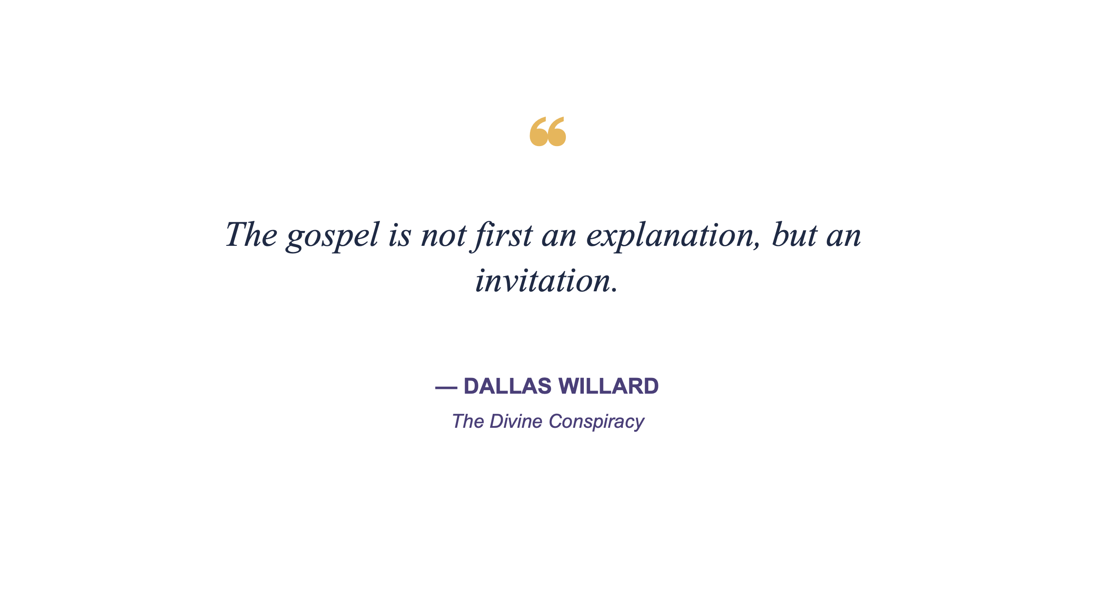

ELEVEN ~ How This Minimalist Gospel Compares to Jesus’ Own Summaries
{Any synthesis must pass Jesus’ own test}

When Jesus summarizes “the Gospel,” He does not lead with mechanics but with an announcement.

1. Jesus’ Core Gospel (Mark 1:14–15)
“The kingdom of God has come near.
Repent and believe the good news.”
Minimalist Jesus-Gospel (7 words):
God’s kingdom is here; respond in trust

2. Jesus’ Mission Statement (Luke 4:18–19)
Good news to the poor…
freedom for captives…
sight for blind…
release for oppressed…
Minimalist Jesus-Gospel (7 words):
God restores broken lives through Christ

3. Jesus’ Call (Mark 8:34)
“Follow me.”
Minimalist Jesus-Gospel (3 words):
Come, follow me

4.. Jesus’ Victory Statement (John 11:25)

“I am the resurrection and the life.”
Minimalist Jesus-Gospel (5 words):
Life conquers death in me

5. Alignment
The earlier 25 expressions of Christianity do not compete with Jesus’ Gospel—they amplify different facets of it:
- Evangelicals emphasize response
- Catholics/Orthodox emphasize participation
- Pentecostals emphasize power
- Liberation traditions emphasize reversal
- Anabaptists emphasize embodiment
Jesus holds all of these without reducing any.

The Integrative Gospel (Jesus Holds All Three)
When Jesus speaks, none of these are separated:
Jesus Christ is Lord—
reconciling sinners,
forming a people,
restoring creation.
Or, in seven words that now reflect everything:

Jesus Christ reigns, restoring people and creation

Most conflict over “this Gospel” arises not from denial but from over-specialization—treating one dimension as the whole.
Mark 13:10 does not ask for:
- theological uniformity
- cultural sameness
- or one institutional expression
It requires a recognizable announcement that can travel across peoples:
Jesus Christ is Lord—and that changes everything.
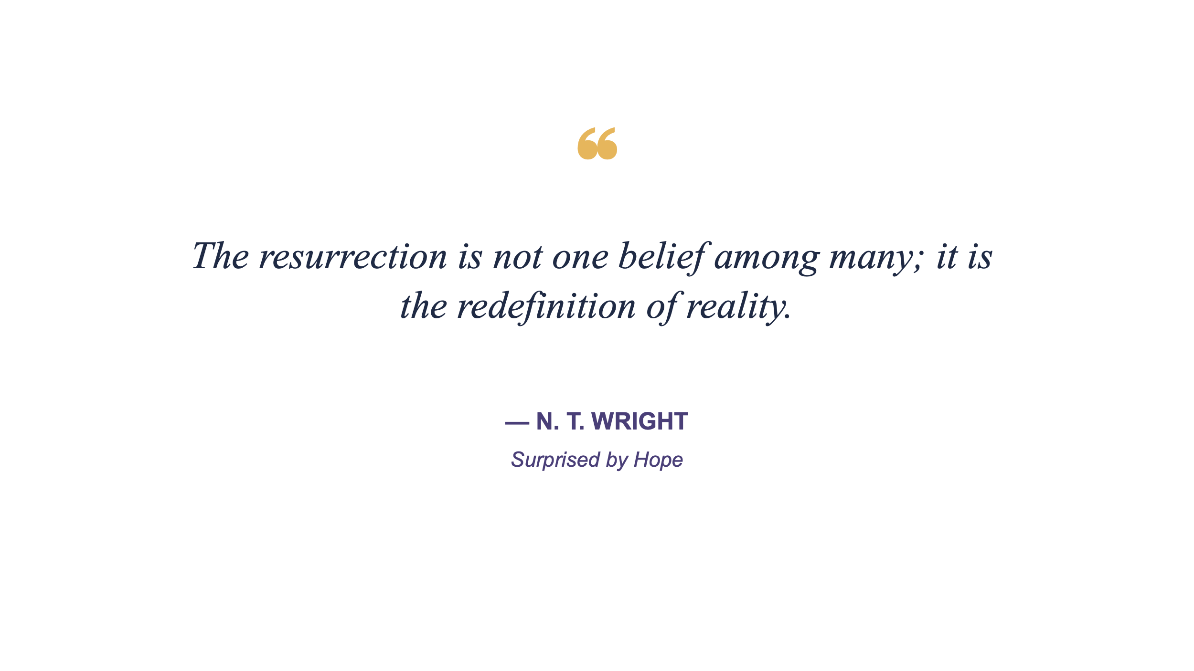

TWELVE ~ Testing the Minimalist Gospel Against Paul’s Own Summaries
{We must apply the same test to Paul}

Using Paul’s explicit Gospel statements (not later doctrinal systems).

1. 1 Corinthians 15:1–5 (Paul’s clearest summary)
“Christ died for our sins…
was buried…
was raised…
appeared…”
Paul’s minimalist Gospel (7 words):
Christ died, rose, reigns for us
Alignment
- Strong vertical (sin, forgiveness)
- Strong historical (events)
- Implicit Lordship (resurrection = reign)
✔ Fully compatible with:
“Jesus Christ is Lord, bringing God’s salvation.”

2. Romans 1:1–4
“The Gospel…
concerning his Son…
declared Son of God with power
by resurrection…”
Paul’s minimalist Gospel (7 words):
Jesus declared Lord through resurrection power
✔ Matches exactly the earliest Christian confession:
Jesus is Lord

3. Romans 1:16–17
“The Gospel…
the power of God for salvation…
righteousness by faith…”
Paul’s minimalist Gospel (5 words):
God’s saving power revealed in Christ
✔ Explains how salvation works, not what replaces Jesus’ announcement.

4. 2 Corinthians 5:17–21
“God was in Christ reconciling the world…”
Paul’s minimalist Gospel (7 words):
God reconciles the world through Christ
✔ Expands beyond individuals → cosmic reconciliation

Paul’s Integrated Gospel (one sentence)
Jesus Christ is risen Lord, reconciling the world to God.
Paul does not narrow Jesus’ Gospel—
he clarifies its implications.
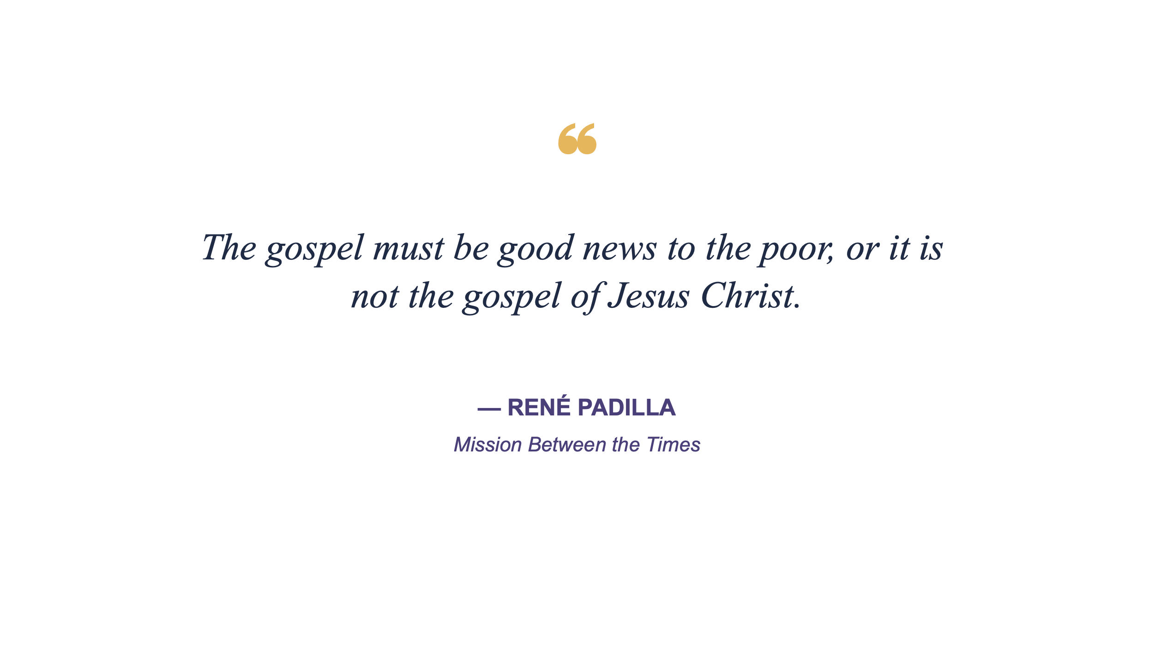THIRTEEN ~ How Mission Agencies Implicitly Choose a Gospel Orientation
{Theology becomes visible in practice}

Most mission debates are not about theology—but about what counts as “the Gospel in practice.”
Below is a diagnostic map, not a critique.

1. Vertical-Dominant Agencies
Core question: “Have they believed?”

Emphases
- Conversion
- Sin, forgiveness
- Decision, proclamation

Typical outcomes
- Evangelism
- Bible translation
- Church planting

Strength
- Clear message
- Reproducible

Risk
- Thin discipleship
- Minimal social imagination

2. Horizontal-Dominant Agencies
Core question: “Are lives and systems changing?”

Emphases
- Justice
- Compassion
- Community development

Typical outcomes
- Relief & development
- Advocacy
- Reconciliation work

Strength
- Visible good news
- Cultural credibility

Risk
- Christological drift
- Gospel assumed, not announced

3. Cosmic-Dominant Agencies
Core question: “Is the kingdom breaking in?”

Emphases
- Power encounter
- Healing, deliverance
- Spiritual warfare
- Renewal

Typical outcomes
- Rapid growth movements
- Indigenous leadership
- Testimony-driven faith

Strength
- Holistic Gospel
- Deep contextual resonance

Risk
- Underdeveloped theology
- Leadership instability

The Missional Insight
Healthy mission requires all three:
Proclamation (vertical)
Embodiment (horizontal)
Expectation (cosmic)
Anything less exports a partial Gospel.

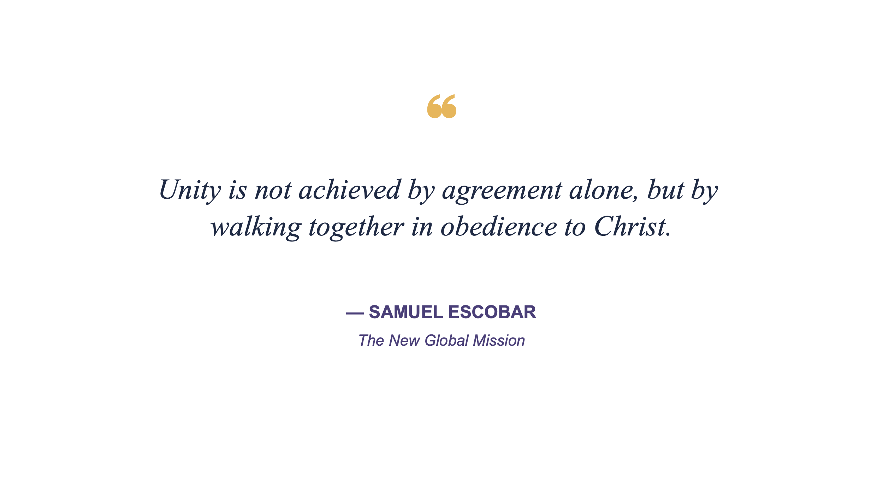

FOURTEEN ~ A Teaching Framework Pastors/Teachers/Leaders
{Without Triggering Defensiveness}

This is designed for:
- Leadership teams
- Mixed theological rooms
- Denominations in transition
No labels first. Experience before explanation.

Step 1 — Start with Jesus’ Announcement
Text: Mark 1:14–15
Ask only this question:
What did Jesus announce before He explained anything?
Let them discover:
- Kingdom
- Nearness
- Response

Step 2 — Introduce the Three Gospel Questions
Instead of definitions, ask:

1. Vertical Question
What does the Gospel save us from and for?

2. Horizontal Question
Who is being formed into a new way of life?

3. Cosmic Question
What is God restoring beyond individuals?
People will recognize their own bias without being accused.

Step 3 — Reveal the Pattern (Not the Camps)
Show this sentence:
Jesus Christ is Lord—
reconciling sinners,
forming a people,
restoring creation.
Then ask:
- Which line do we emphasize?
- Which do we neglect?
- What might faithfulness require now?

Step 4 — Return to Mark 13:10
Ask the integrative question:
If “this Gospel” must reach all peoples, what makes it recognizable across cultures?
They will arrive at:
- Jesus
- Lordship
- Good news
- Response

Step 5 — End With a Confession (Not a Statement)
Invite the room to say together:
Jesus Christ is Lord.
Not as dogma.
As alignment.

Final Integrative Sentence
If you ever need one line that holds everything you’ve been surfacing:
The Gospel is the announcement that Jesus Christ is Lord,
and God is restoring all things through Him.
That line can:
- Travel cross-culturally
- Sit under Mark, Paul, and Jesus
- Invite conversation instead of division
You’re not simplifying the Gospel—you’re recovering its center.

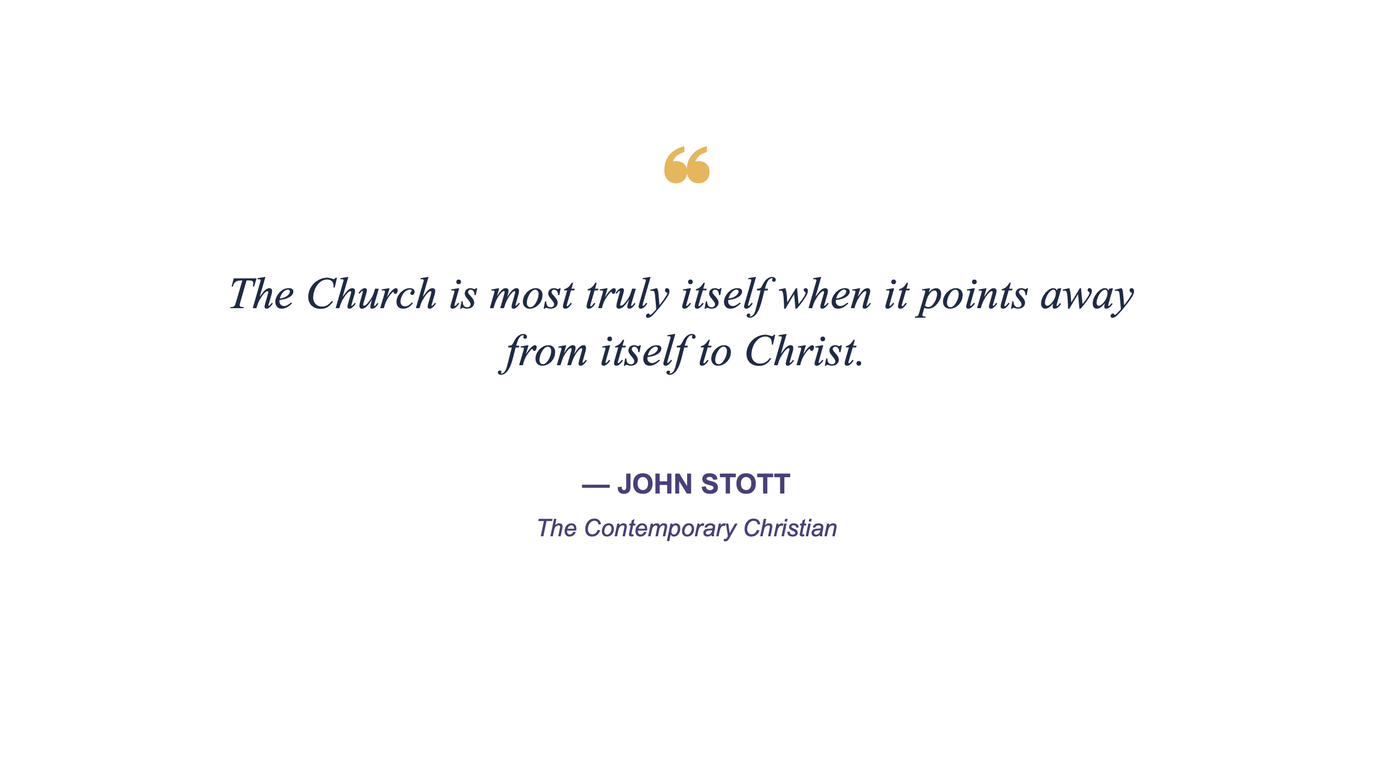

FIFTEEN ~ A Unifying Perspective that Redescribes Unity
{We return to where we began, where we were born from above, the Gospel … because unity is not complete uniformity—it is our shared spiritual identify}
Across all these expressions, “this Gospel” consistently includes:
- Jesus Christ at the center
- Good news, not mere information
- A call to response (faith, repentance, allegiance, obedience)
- A global scope—for all peoples
Yet the emphases differ: forgiveness, kingdom, liberation, holiness, healing, justice, communion, transformation, or victory.

Why This Gospel Matters Now
“Jesus Christ is the same yesterday and today and forever.” (Hebrews 13:8)
In a fragmented world, the Church does not need a smaller Gospel but a clearer one.
The Gospel is the announcement that Jesus Christ is Lord and that God is restoring all things through Him.
This Gospel can travel anywhere, speak to anyone, and still be recognized as good news.
“Every tongue acknowledge that Jesus Christ is Lord, to the glory of God the Father.” (Philippians 2:9–11)

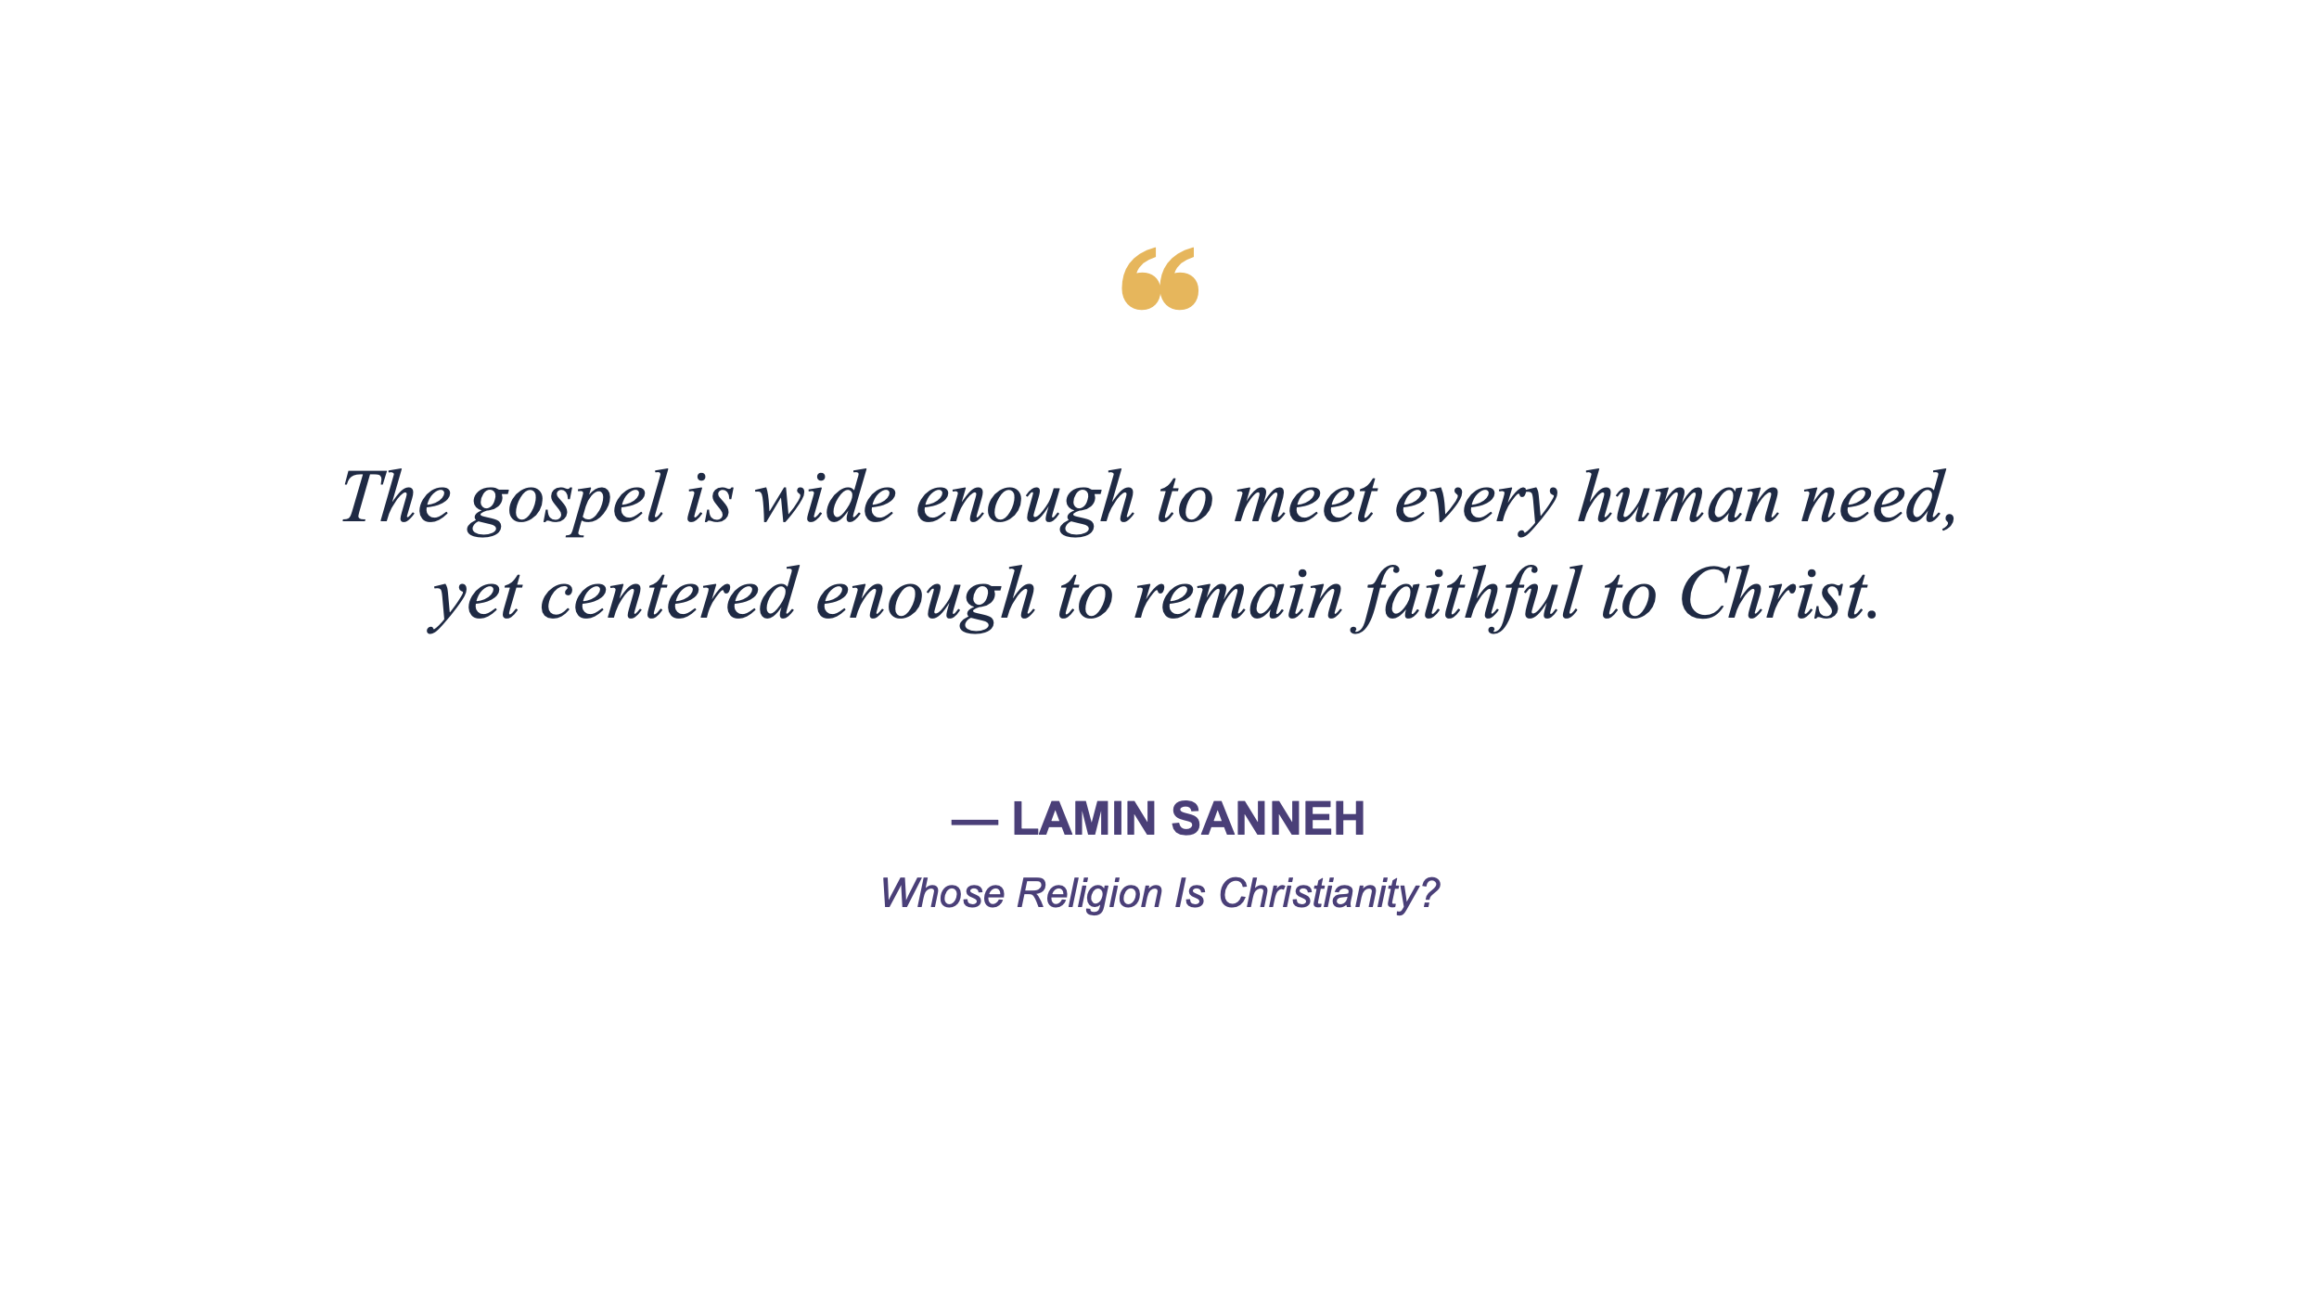

•BONUS: The Parable of the Ice Cream Shop
{The mind needs imagination to understand and apply analysis}}

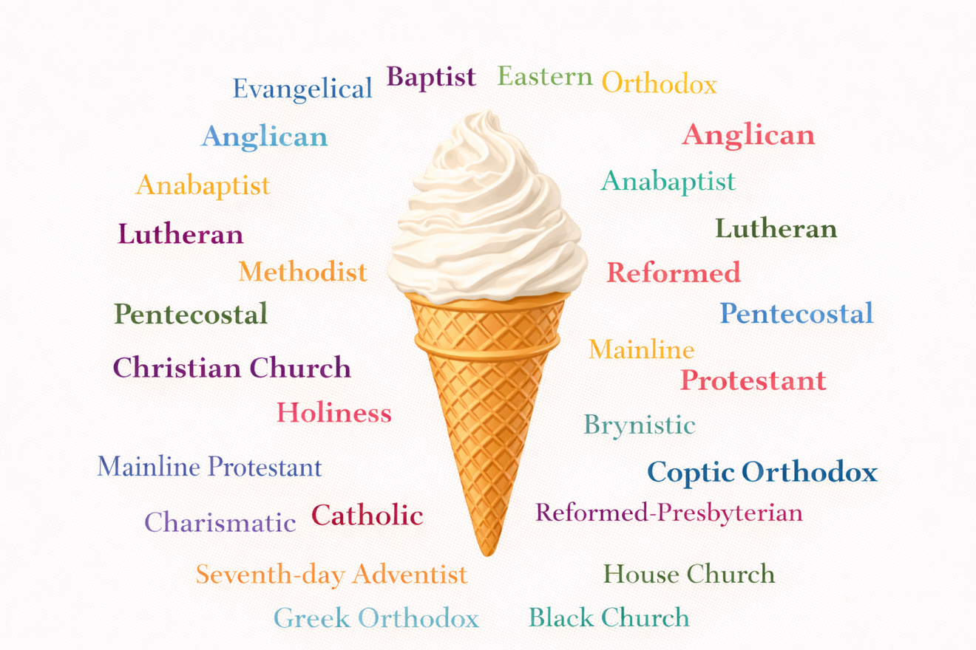

The Point of the Parable
The Gospel is the ice cream, not the flavor.
Christian traditions are not different desserts—
they are different ways the same goodness is tasted.
Some people need certainty.
Some need balance.
Some need simplicity with depth.
Some need healing.
Some need justice.
Some need mystery.
The danger is not loving a flavor.
The danger is insisting your flavor is the only proof sweetness exists. And forgetting the ice cream is the gift of a gracious, loving shopkeeper who desires the store keeps drawing people through the door.

1️⃣ Teaching Illustration for Pastors
(Clear, reflective, discussion-ready)

The Ice Cream Shop and the Gospel
Imagine the Gospel as an ice cream shop offering 31 flavors.
The shop itself never changes.
The ingredients come from the same source.
But people walk in carrying different tastes or cravings.
Some choose chocolate only. They want certainty. They’ve found something that works, and they trust it. Chocolate feels reliable, familiar, strong.
Others choose Neapolitan. They want balance—multiple flavors held together. They distrust extremes and prefer harmony.
Some choose vanilla, but only with peanut butter mixed in. They value simplicity, but they also need depth. Plain answers are not enough for the life they’ve lived.
Others choose flavors most people ignore—pistachio, rum raisin, mint chip. They’ve tasted disappointment before. They’re careful. They want something honest, not flashy.
The point is this:
- They are not choosing different foods
- They are responding to the same hunger but with different taste buds
The Gospel is the shop, not the flavor.
Different expressions of Christianity do not compete with one another—they serve different people at different moments.
•Discussion question for leaders:
Are we guarding the shop—or defending a flavor?

2️⃣ Sermon / Podcast Version
(Tighter, more rhythmic, spoken-word friendly)

31 Flavors, One Craving/Hunger
There’s an ice cream shop on the corner with a sign that reads:
31 Flavors.
Some people walk straight in and say,
“Chocolate. Always chocolate.”
Others hesitate.
“I’ll take Neapolitan—I want more than one flavor.”
Some say,
“Vanilla… but not plain. Vanilla with peanut butter.”
Others choose flavors no one talks about.
And some stand outside saying they don’t like ice cream at all—
until someone hands them a spoon.
They argue inside the shop.
Which flavor is best.
Which one is real.
Which one counts.
But the shopkeeper knows the truth.
They all came because they were hungry.
Same milk.
Different recipes.
The Gospel is not the flavor.
The Gospel is the goodness that keeps bringing people through the door.
And the tragedy isn’t loving your favorite flavor.
It’s forgetting why the shop exists at all.

3️⃣ Jesus-Style Parable
(Shorter, more indirect, leaving space for reflection)

The Parable of the Many Flavors
Jesus said:
“The kingdom of God is like an ice cream shop with many flavors.
People entered and chose what they loved.
Some wanted only one flavor.
Some wanted several together.
Some needed sweetness mixed with strength.
They argued with one another about which flavor was true.
But the owner said,
‘You all came because you were hungry.
Do not despise the taste that brought another inside.’”
And Jesus said, “Whoever has ears to hear, let them hear.”

4️⃣ Explicit Mapping to Christian Traditions
(Clear, educational)

31 Flavors, One Gospel
- Chocolate-only → traditions emphasizing certainty, clarity, doctrinal precision
- Neapolitan → traditions holding together Scripture, sacrament, community, and mission
- Vanilla with peanut butter → simple Gospel language enriched by spiritual depth
- Fruit flavors → justice-oriented expressions focused on renewal and restoration
- Mint, pistachio, rum raisin → contemplative, liturgical, or historic traditions
- Kids choosing bright flavors → seekers drawn by joy and belonging
- Those standing outside → skeptics needing patience and invitation
All are responding to the same hunger:
- forgiveness
- meaning
- belonging
- hope
The danger is not diversity.
The danger is confusing preference with exclusivity.
The Gospel is the shop.
Christ is the source.
The flavors are mercy in many forms.

* Why the Flavors Matter—and Why the Shop Matters More
The danger facing the Church today is not diversity of expression.
It is confusion of preference with exclusivity.
Christian traditions are not competing Gospels.
They are distinct ways the same goodness is tasted.
Some people need clarity before they can trust.
Some need belonging before they can believe.
Some need justice before they can hear.
Some need mystery before they can hope.
The tragedy is not loving a particular flavor.
The tragedy is insisting your flavor is the only proof sweetness exists.
The Gospel is not the flavor.
The Gospel is the goodness that keeps drawing people through the door.
And Christ is not a recipe among many.
Christ is the source.
This is why the Church must guard the center without flattening the edges.
Why unity does not require uniformity.
Why faithfulness must always leave room for welcome.
Because the hunger remains.
And the door is still open.
“Taste and see that the Lord is good.” (Psalm 34:8)

* Discussion & Reflection Questions (Facilitator Edition)

Personal Reflection
- Which “flavor” of Christianity most nourished you early in your faith?
- Has your taste changed over time? Why?
- What hunger was that expression meeting for you?

Group Discussion
- Where do we tend to defend a flavor rather than protect the shop?
- Which people might feel unwelcome because our preferred flavor dominates?
- How can we remain clear about Christ while remaining generous toward difference?

Leadership Application
- In our ministry, are we prioritizing familiarity or hospitality?
- What would it look like to widen the menu without losing the source?
- How does this metaphor reshape how we think about Mark 13:10?

•BONUS ~ Suggestions on Pursuing Unity

EXPRESS THE UNITY OF THE CHURCH
Not Conformity-of-Theology but . . .
Phil Miglioratti

{PRELUDE}
#ItSeemsToMe... when Jesus prayed for the unity of the #Church,
he was not expecting total conformity (the mix of his disciples were diverse for that time and culture)
but was anticipating authentic relationships (one another in Christ), information sharing, humility,
and a "quick to listen-slow to speak-slow to anger [patient, reflective, forgiving] attitude of respect."

The 1990s saw a fresh awareness among catalytic leaders of the need to cast vision beyond single-congregation evangelism or community impact.
This Holy Spirit perspective gave rise to a movement that continues to this day; "cityreaching."
In its infant stage, cityreaching had a "we will take our cities for God!" mindset. As the movement matured, the "for God" remained but the "taking" was replaced by "serving." Citywide actions-projects-events were often fueled by a prayer-care-share lifestyle mindset that influenced disciple-making models and impacted evangelistic training. City Impact Roundtable and Conference calls brought a diversity of leaders together for prayer and relationships as well as thought leaders and best practices.
Examples of national platforms include: Mission America Coalition, Seek God for the City, Movement Day, City Gospel Movements, Loving Our Communities for Christ, Christ Together, City Advance . . .
Examples of regional/local platforms include: Serve The City (Cedar rapids), Together (Rhode Island), Explore God Chicago, Ready Indy, Milwaukee Believes, Love INC (Fresno), El Paso for Jesus, Love Fox Valley (Illinois; Wisconsin) . . .
These initiatives have resulted in a variety of role functions, such as Coordinators, Directors, Coaches, Leader, but seldom has someone devoted their focus and energies toward facilitating.
- Facilitating communication across the Church
- Facilitating connections to build authentic Kingdom relationships
- Facilitating partnerships that result in equipping, expanding or extending ministry
A full-time-focus facilitator has the privilege of lifting any and potentially every congregation and organization in the region. In other words, that facilitator's task is to seed and feed but not lead.
- Appoint or recruit other gifted persons to take the "top" role
- This allows you to serve others, free from the tasks and time of administration
- This allows you to focus on inviting still others into the movement, at their level of interest or their capacity of ministry.
- That keeps you from taking the role of Chief Shepherd of the movement; leave that to the true Cityrecher, our Lord Jesus
As this river of many tributaries continues to flow, city movement champions must carry learned insights from the past as they seek Holy Spirit discernment for the future.

I invite you to consider these five "Cs" as a guide toward catalyzing a movement of movements across a community or city.
- CONTACT
- CONNECT
- COORDINATE
- COOPERATE
- COLLABORATE

CONTACT
- Our first objective must be to make a collegial contact with as many potential ministry partners as possible. Pastors. Ministry CEOs. Community activists. Social services. Neighborhood groups.
- How can I/we serve your vision?
- Help us tell your story
- Goal: to understand what God is doing across the city/region:
  - Micro (congregation, team, group)
  - Mezzo (mezzanine; organizations, ministries, services)
  - Macro (area-wide events and programs)
CONNECT
- ...so that, we can build a data base for communication that
  - Introduces leaders to one another
  - Informs the Church of the vision/purpose of the wide diversity of ministries and congregations across their city/region
  - Invites participation on a
    - Micro level (Pastors' Prayer groups)
    - Mezzo level (local or affinity clusters)
    - Macro level (seasonal events, holiday programs)

COOPERATE
- Two or more entities (congregations, organizations, associations) assisting another ministry/agency
- One entity promoting a concert or conference of another church/ministry
- Several entities provide volunteers for an under-resourced ministry program

COORDINATE
- Two or more entities participating together in a project or event: Same thing-Same-time. Same place.
- Church Pantries making bulk purchases or sharing a common facility
- Congregations committing to an initiative (for example, Explore God: same curriculum and dates, but no interaction between participating groups

COLLABORATE
- Two or more entities together developing a plan/program to meet a need
- Entities combine under a common-name-banner to remove graffiti in a neighborhood
- Entity invites the community (individuals and agencies) to brainstorm solutions to a local problem, design a strategy to minimize that need, then participate in the implementation of that strategy
None of this is new to the community impact movement.
What would be "new" is to insert free-ranging facilitators.
No role to be consumed by. No risk to other recognized leaders.
No desire to create a new organization or compete with current initiatives.
A person fueled by a desire to lift-up the work of the Body of Christ, whether micro (a store front church), mezzo (a single-focus ministry that serves the region), or macro (big in scope and size).
Could that be you?
Add this to your prayer-list?

Pursuing Unity
The unity of the Church is a reality of our spiritual identity. It is not determined by your systematic theology.
Unity is in the DNA of the Church of Jesus Christ, but uniformity is the DNA of most expressions of Christianity.

5 "Cs" to Engage Your Community
A guide toward catalyzing a movement across a community or city

1. CONTACT - information
2. CONNECT - interaction
3. COORDINATE -calendar
4. COOPERATE - events
5. COLLABORATE - projects

What if God is at work through the diversity of the Church, not against it?
“And we know that in all things God works for the good of those who love him, who have been called according to his purpose.” (Romans‬ 8‬:28‬ )‬‬‬‬‬‬‬‬‬‬‬‬‬‬‬‬‬‬‬‬‬‬‬‬‬‬‬‬

My response about how to pursue a citywide ministry . . .

Regarding collaboration…

I found difficulties in city after city with getting groups with very different DNA to work together. Different styles. Struggles with submission. One-size-fits-all.

If I was coaching a citywide movement, I would ask them to examine the different categories of working together.

*Connecting- building cross-cultural relationships (ethnic, neighborhood, leadership style, ministry approach, etc.). [Relating]

*Communicating - leaders share information and begin to promote each other’s activities-events-training, etc. [Promoting]

*Cooperation - everyone retains their DNA but welcomes participation by other groups. [Inviting]

*Coordination- groups retain their distinctives but mobilize prayer or outreach around the same theme at the same time. [Scheduling]

*Collaboration- leaders meet with a blank planning sheet and seek a Spirit-led vision through prayer; no one “sells” their program…something new is built. [Unifying]

In a war, each military division retains its calling but works closely with the other divisions. Each agency infiltrates based on their functionality. The Navy attacks from the water, Air Force from the skies, Army advancing by ground, Marines and Rangers stealthily taking down strategic sites. They each do their “thing” but with much communication and coordination.

In the Body of Christ we seem to define unity as other ministries and entities joining our vision or employing our strategy, which makes sense to us but requires them to set aside their vision and submit to our agenda.

True collaboration is a grand goal but much can be achieved by connecting (talk, relate, honor one another) and communicating (share information, results). Every stage on the collaboration scale is an opportunity for the Body of Christ to serve our Lord together.

Your thoughts?

Phil Miglioratti
The Reimagine.Network

Related:
The Body of Christ: A Partnership of Congregations
Transition to a Deep-and-Wide Discipleship Spectrum
5 C’s of Unified Action

•BONUS ~ The Parable of God’s Global Choir
I saw a great choir—so large no one could count its members.
They were gathered from every nation, tribe, people, and language of the earth.
The Revelation of Jesus 7:9
They did not arrive together.
Some came dancing.
Some came limping.
Some were carried.
Some arrived quietly and stood at the edges, unsure they belonged.
They wore different clothing.
Some wore robes stitched with gold thread.
Some wore suits and dresses pressed with care.
Some wore jeans faded from long use.
Some wore sackcloth, still marked by grief.
They spoke different languages.
Some sang in tones shaped by centuries of liturgy.
Some lifted voices in simple choruses learned by heart.
Some sang with orchestras, others with drums, others with nothing but breath.
Some sang in major keys that sounded like joy.
Others sang in minor keys that sounded like lament.
Not everyone sang loudly.
Not everyone sang on pitch.
Not everyone sang at all.
Some listened as their act of praise.
There were wealthy voices trained by years of instruction
and fragile voices shaped by disability or age.
There were scholars who knew the music by sight
and children who followed only by sound.
At first, it sounded like chaos.
Observers stepped back and whispered,
“This is not unity.”
“They are not singing the same way.”
“They are not even in the same key.”
But then the Conductor lifted His hands.
And something became clear.
They were all singing the same song.
Not in the same language.
Not with the same rhythm.
Not with the same instruments.
Not even with the same interpretation.
But it was unmistakably the same song: Amazing Grace.
Grace sung in Spanish with guitar.
Grace sung in Korean with careful harmony.
Grace sung in African rhythms that moved the body.
Grace sung in silence by those whose voices had been taken,
but whose hearts still remembered the melody.
Some sang only the first verse.
Some lingered on the last.
Some repeated the refrain, again and again,
as if afraid to let it go.
They differed on tempo.
They differed on arrangement.
They differed on what accompaniment was appropriate.
But no one sang of a different grace.
And then I realized something essential:
The unity of the choir was not created by uniformity.
It was created by identity.
They did not agree on tempo or harmony.
They did not agree on whether to hold sheet music or have hands free to life in praise.
They did not agree on where the choir should sing from in the sanctuary (Back? Font? Facing the side walls?)
But they knew who they were.
They were the redeemed.
They were the reconciled.
They were the ones for whom grace was not doctrine but rescue.
The Conductor did not silence their differences.
He wove them together.
And the sound—the sound was fuller than any single style could ever be.

What the Parable Reveals
Jesus was never praying for a united church built on uniformity.
Uniformity silences.
Uniformity excludes.
Uniformity assumes God favors one culture, one voice, one expression.
Scripture’s vision of the Church is far richer:
“I saw a great multitude that no one could count, from every nation, tribe, people, and language…”
Unity, in the Kingdom of God, is not agreement on every secondary issue or tertiary detail.
Unity is shared identity.
And that identity is not a worship style.
Not a theological system.
Not a cultural expression.
It is the Gospel.
Because God loves every people in every place,
the Gospel must be spacious enough to be sung in every language,
embodied in every culture,
and expressed through joy, silence, lament, movement, and rest.
Red. Yellow. Black. Brown. White.
All precious in the Father’s sight—not because they are the same,
but because they are loved the same.

A Necessary Theological Turn
This is where many evangelicals struggle.
Every authentic Christian shares two identical characteristics:
- Each of us has a sincere faith
that God was in Christ, reconciling the world to Himself.
- Each of us holds sincere but imperfect beliefs
shaped by language, culture, history, translation, and interpretation, even tradition.
The trouble begins when we confuse the two.
When we begin to believe not only in Christ,
but in our beliefs about Christ.
When we assume that because Scripture is true,
our reading of Scripture must therefore be true in every detail,
That’s when faith quietly shifts into certainty.
And certainty, when unexamined, becomes fragile.
And fragility, when threatened, becomes defensive.
That is how communities stop listening.
That is how we conclude that the only options are our view or error.
We forget to ask:
- What if we translated imperfectly?
- What if we interpreted partially?
- What if we applied prematurely?
- What if God prefers belief proclaimed with both certainty and humility?
The disciples in Scripture first followed Jesus; theological descriptions came later. The early Church trusted God before it systematized doctrine.
Which means humility is not a threat to faith.
It is its companion.

Why This Matters for Reconstructing Faith
If we believe that unity requires uniformity,
then difference becomes danger.
But if unity flows from identity in the Gospel,
then difference becomes gift.
The choir does not need fewer voices.
It needs deeper listening.
The Church does not need less theology.
It needs theology held with humility—
strong enough to confess Christ,
gentle enough to keep learning.
That is not relativism.
That is reverence.
And perhaps this is part of what it means
to ReCenter Christ—not merely to refocus on Him,
but to let His reconciling presence
be the center from which all our differences
find their place.



Reimagination Starts Here . . .
8 Questions to Jump-Start Your Re-View and Re-Examination of
Perspectives and Presumptions that Drive Your Spiritual Life and Ministry

√ Why should I/our church reimagine?
Answer this question before you go looking for solutions…
√ How can I search Reimagine.Network to interact with thought-provoking perspectives?
Where to find what you need. Quick-access.
√ How do we begin to “be not conformed”?
Every new journey needs to leave some things behind {scroll options}
√ How do we pursue being “transformed by a renewed mindset”?
Navigate these four distinct paths to invite everyone on a spiritual journey of transformation
√ Why do we need different questions to discover better answers?
Reimagining Begins With Better Questions, Not Prefab Answers
√ How do I cast vision in a way that involves others in the process?
Convene conversations and group discussions with: Leader Labs * Mini-Courses * Seminar Slides * Workshop Templates {scroll list}
√ How do we recenter Christ in every family, ministry, activity?
Seeking Christ’s presence so that we serve Christ’s Kingdom purposes
√ How do we rethink how we pray-think-plan our ministries of prayer, disciple making, evangelism, missional outreach?
New thinking about Prayer, Ministry, Discipleship, Evangelism, Community Impact . . . {3-5 minute reads}

- Scan top Menu for - Home/Portal
PRAYER CHAMPIONS - MAKING DISCIPLES - MISSIONAL OUTREACH
THINK TANK - MINISTRY HUB: Tools/Resources – GET CONNECTED

© Phil Miglioratti • 2026 • Permission Granted for Posting-Projecting-Printing

